Insert Menu

Insert menu provide the tools to used insert them directly such as pivot table, Table, shapes, smart Art, Chart, slicer and symbol etc.

Where pivot table, chart and slicer are very important for analysis the data to generate the report

Chart is used for visualization of the data and slicer is apply on pivot table for filter the data from pivot table

## Pivot Table

Pivot Table is used to **Summarize the Data** which are given in the table

Summarize means analysis record of the Table **to generate the Report**  
Data for Pivot table

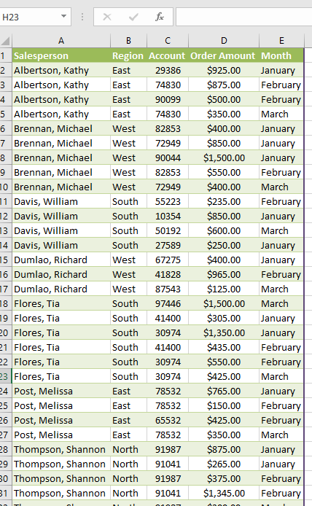

## To Apply the pivot table on data, follow below steps:

Select data-> insert menu->**Pivot table** or we can choose **Recommended Pivot table**

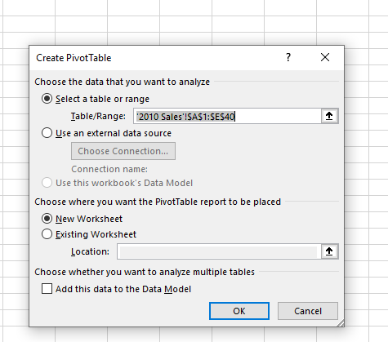

Above Diagram show when select the pivot table **there need to select the Range of data** and also Location of pivot table either existing sheet or new Work sheet

After that need to manage the pivot table summation of the value and also set the row and column according to the requirement

Such as given below:

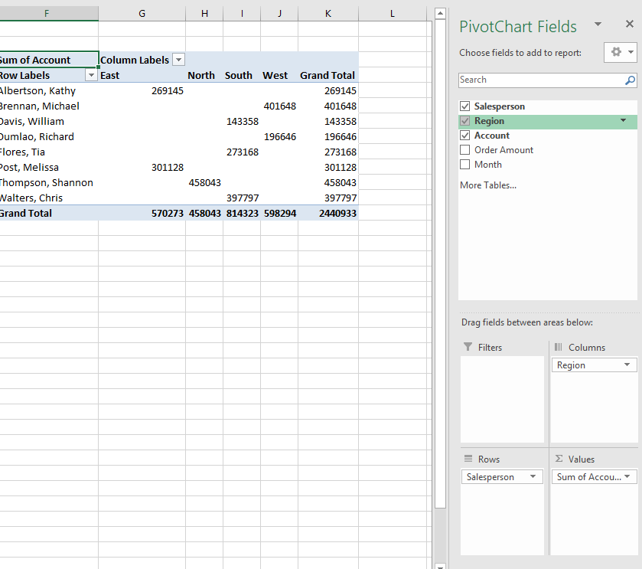

## Note: Recommended Pivot table provide **Hint** to get Summary of the data

That means **recommended pivot** table is more easy than manual

# Slicer:

It used to filter the data from pivot table

**Note:** -Before Apply the slicer, you should ensure that your pivot table should be ready.

Select pivot table->Insert menu->slicer->check filter column->ok

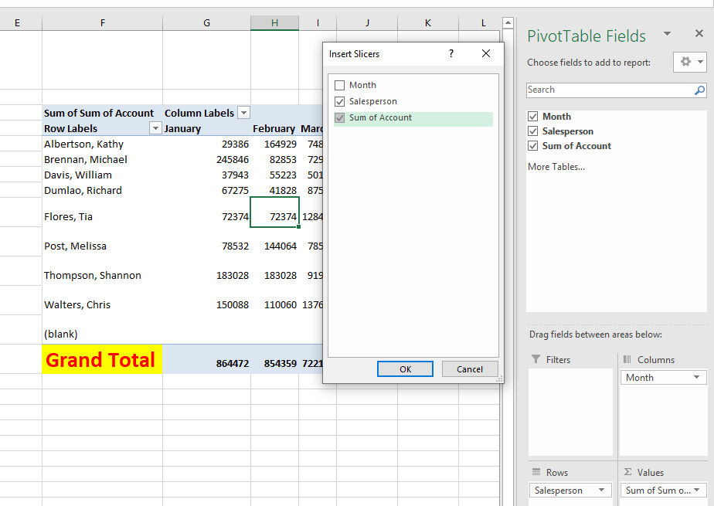

# Practices Work:

Find the pivot table such as given bellow using slicer

# 

# Chart

Chart is used for graphical representation of the data

Select Data-> Insert menu-> Recommended Chart-> choose and insert

Link

**Link: It is used to the linking an external file or we can also link in the same file with other work sheet**

# Step First:

**Select the Text form Cell**-> Insert Menu-> Link->Select the external file from your computer

# Link in Existing File with work sheet:

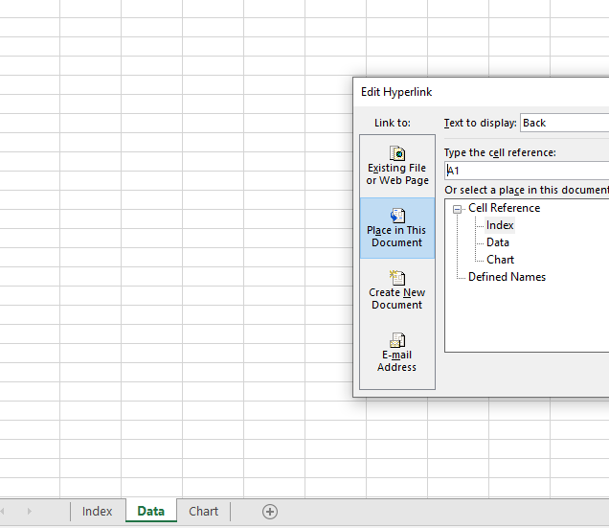

# Second Step:

**Insert menu->**Link-> Place in this Document **-> Select the cell Reference with work sheet-**>Ok

